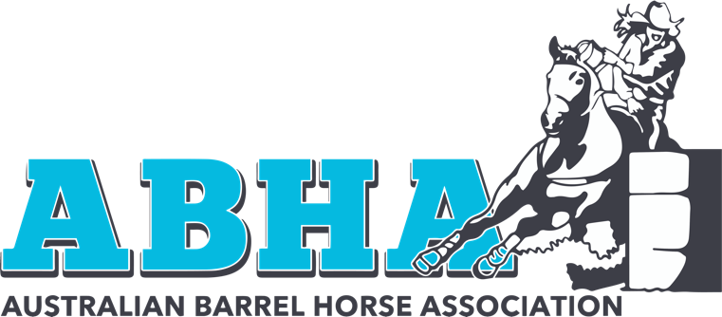
9th May 2023,

To All our Affiliates, Competitors and Members,
Please be advised that the qualifying period has been extended by two days to incorporate the weekend of the 1st and 2nd of July 2023.
This gives our members an extra chance to qualify given that our previous cut off date was mid-week.
This also gives our current affiliates one last chance to run a qualifier event should they so wish.
We would like to thank all our affiliates for doing such a great job in planning and running these events through the year and look forward to working with you all in the future.
See you at the finals!

Kind Regards,

The Board of Directors
Australian Barrel Horse Association

